How to interpret (in detail!) the following outputs of a linear regression in R?

##################### # Interpret regression outputs
### First step: ALWAYS check the data first (distribution, outliers etc.) before you even do a regression!
### Second step: When doing a regression, don’t only focus on the numeric outputs, ALWAYS check the model diagnostics plots!

#2) Logistic regression:

library(ISLR)
head(Default)
# -> data set for log. reg.
levels(Default$default) #"No" is the reference category.

logreg_default <- glm(default ~ balance + income + student, family = binomial, data = Default)
summary(logreg_default)

Call:
glm(formula = default ~ balance + income + student, family = binomial,
data = Default)

Coefficients:
Estimate Std. Error z value Pr(>|z|)
(Intercept) -1.087e+01 4.923e-01 -22.080 < 2e-16 ***
balance 5.737e-03 2.319e-04 24.738 < 2e-16 ***
income 3.033e-06 8.203e-06 0.370 0.71152
studentYes -6.468e-01 2.363e-01 -2.738 0.00619 **
---
Signif. codes: 0 ‘***’ 0.001 ‘**’ 0.01 ‘*’ 0.05 ‘.’ 0.1 ‘ ’ 1

(Dispersion parameter for binomial family taken to be 1)

Null deviance: 2920.6 on 9999 degrees of freedom
Residual deviance: 1571.5 on 9996 degrees of freedom
AIC: 1579.5

Number of Fisher Scoring iterations: 8

> coef(logreg_default)
(Intercept) balance income studentYes
-1.086905e+01 5.736505e-03 3.033450e-06 -6.467758e-01

> exp(coef(logreg_default))
(Intercept) balance income studentYes
1.903854e-05 1.005753e+00 1.000003e+00 5.237317e-01

> confint(logreg_default)
Waiting for profiling to be done...
2.5 % 97.5 %
(Intercept) -1.185902e+01 -9.928174e+00
balance 5.294898e-03 6.204587e-03
income -1.304712e-05 1.912447e-05
studentYes -1.109018e+00 -1.822147e-01
> exp(confint(logreg_default))
Waiting for profiling to be done...
2.5 % 97.5 %
(Intercept) 7.074481e-06 0.0000487808
balance 1.005309e+00 1.0062238757
income 9.999870e-01 1.0000191246
studentYes 3.298827e-01 0.8334223982
> #To change the reference category (which is not useful here):
> #Default$default <- relevel(Default$default, ref = "Yes")

Interpretation:

- Response: default, a factor with levels "No" and "Yes".
  - R treats "No" as 0 and "Yes" as 1.
  - The model is about the probability of default = "Yes".
- Predictors:
  - balance: average credit card balance.
  - income: income.
  - student: factor (No/Yes), with "No" as the reference level. So the coefficient studentYes compares students to non-students.
The logistic regression equation is:

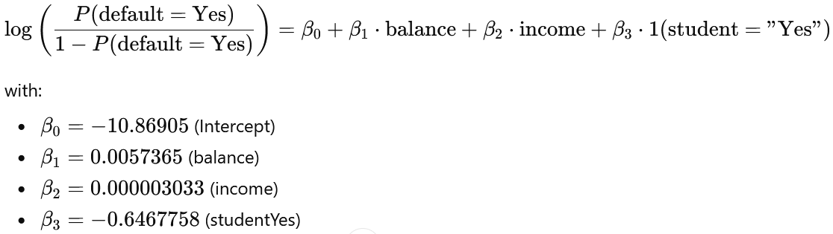

2. Coefficients on the log-odds scale
From the summary():
Estimate Std. Error z value Pr(>|z|)
(Intercept) -10.87 0.4923 -22.08 < 2e-16 ***
balance 0.00574 0.000232 24.74 < 2e-16 ***
income 0.00000303 0.0000082 0.37 0.71
studentYes -0.647 0.2363 -2.74 0.006 **

Interpretation (log-odds):
- Intercept (-10.87)
  - This is the log-odds of defaulting for a non-student with balance = 0 and income = 0.
  - That combination of predictors is not realistic, so the intercept itself usually isn’t of substantive interest—it just anchors the model.
- Balance (0.00574)
  - For each additional 1 unit of balance (e.g., $1 if balance is in dollars), the log-odds of default increase by 0.00574, holding income and student status fixed.
  - Positive coefficient ⇒ higher balance → higher chance of default.
- Income (0.00000303)
  - For each 1 unit increase in income, the log-odds of default increase by 0.000003 (essentially zero), holding the others fixed.
  - The z-value is very small and p ≈ 0.71 → not statistically significant in this model.
- StudentYes (-0.647)
  - Being a student (vs non-student), at the same balance and income, reduces the log-odds of default by 0.647.
  - Negative coefficient ⇒ students are less likely to default than non-students, conditional on balance and income.

3. Odds ratios (exp(coef))
You computed:
exp(coef(logreg_default))
(Intercept) balance income studentYes
1.903854e-05 1.005753e+00 1.000003e+00 5.237317e-01

These are multiplicative effects on the odds of default:
- Balance: OR = 1.00575 per 1 unit of balance
  - For each additional 1 unit of balance, the odds of default are multiplied by 1.00575 (~0.575% increase).
  - More intuitive: per 100 units of balance:
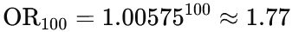
→ 100 more units of balance ≈ 77% higher odds of default (holding income & student status constant).
- Income: OR = 1.000003 per 1 unit of income
  - A 1-unit increase in income barely changes the odds.
  - Even per 10,000 units of income, the effect is modest and statistically non-significant:
    - Roughly OR ≈ 1.03 for +10,000 units.
  - Since the p-value is 0.71, we cannot confidently claim that income is related to default conditional on balance and student.
- StudentYes: OR = 0.524
  - Students have about 48% lower odds of default than non-students with the same balance and income:
    - 0.524 = 52.4% of the odds → odds reduced by ~47.6%.
- Intercept: OR = 1.9e-05
  - This is the odds of default when balance = income = 0 and student = "No". Again, not directly meaningful; it just sets the baseline.

4. Confidence intervals for coefficients and odds ratios
You ran:
confint(logreg_default)
(on log-odds scale) and:
exp(confint(logreg_default))
(on odds scale):
On the odds scale:
2.5 % 97.5 %
(Intercept) 7.07e-06 4.88e-05
balance 1.005309 1.006224
income 0.999987 1.000019
studentYes 0.329883 0.833422
Interpretation:
- Balance
  - 95% CI for OR: [1.0053, 1.0062] per 1 unit of balance.
  - The entire interval is > 1 → we are very confident that higher balance is associated with higher odds of default.
- Income
  - 95% CI for OR: [0.999987, 1.000019], which is essentially centered around 1.
  - Because 1 lies comfortably inside this interval, income’s effect is statistically indistinguishable from zero at the 5% level.
- StudentYes
  - 95% CI for OR: [0.33, 0.83].
  - Entire interval is < 1 → strong evidence that being a student reduces the odds of default, after adjusting for balance and income.
  - Quantitatively: depending on where in the interval, students have between ~17% and ~67% lower odds of default than comparable non-students.

5. Overall model fit: deviance and AIC
From the summary:
Null deviance: 2920.6 on 9999 degrees of freedom
Residual deviance: 1571.5 on 9996 degrees of freedom
AIC: 1579.5
- Null deviance (2920.6, df = 9999)
  - Fit of a model with no predictors (only an intercept).
  - Think of this as a baseline reference.
- Residual deviance (1571.5, df = 9996)
  - Fit of the full model with balance, income, and student.
  - Lower deviance = better fit.
- Model improvement:
  - Drop in deviance = 2920.6 − 1571.5 = 1349.1 on 3 df.
  - This is like a likelihood ratio test. The associated p-value is effectively 0 (far below 0.001), meaning:
    - The predictors as a group significantly improve the model compared with using only an intercept.
- Pseudo-R^2 (McFadden-style)
So the model explains about 46% of the deviance in default outcomes—pretty substantial for a binary outcome.
- AIC (1579.5)
  - AIC = deviance + 2 × number of parameters.
  - Lower AIC is better relative to other models on the same data (e.g., if you compare with a model that uses balance only, or adds interactions, etc.). By itself, it’s mainly a number for comparison, not interpretation.

6. Putting it in plain language
Summarizing the story:
- The model estimates the probability that someone defaults on their credit card (Yes) as a function of their balance, income, and student status.
- Balance is the dominant predictor.
  - As balance increases, the probability of default rises sharply.
  - Even modest increases in balance lead to noticeably higher odds of default; a 100-unit increase in balance boosts the odds of default by ~77%, holding other variables constant.
- Income, after accounting for balance and student status, doesn’t show a clear effect.
  - Its coefficient is tiny and statistically non-significant.
  - Practically, in this model, knowing income doesn’t add much predictive power once you already know balance.
- Student status matters, but maybe not in the way you’d guess from raw data.
  - Once you control for balance and income, students have substantially lower odds of default than comparable non-students (about half the odds, with a 95% CI of about one-third to five-sixths).
  - This can be an example of confounding: if students tend to have different balances on average, the raw default rates might look one way, but after adjusting for balance, the effect flips or changes.

7. Example prediction (to build intuition)
Within this model, suppose we compare two people with the same income and balance:
- Person A: non-student
- Person B: student
Let’s say balance = 1500, income = 40,000 (units consistent with your data).
Using the model:
- Predicted P(default) for the non-student ≈ 0.105 (about 10.5%).
- Predicted P(default) for the student ≈ 0.058 (about 5.8%).
So, at the same balance and income, the model predicts the student is roughly half as likely to default as the non-student – consistent with the odds ratio of about 0.52.

